Pupil Progress and Achievement Information -
Key Stage 5

(2017 / 2018)
Headline Results
- The vast majority of pupils are on track to meet or exceed expected outcomes against other Post-16 pupils nationwide within the CASPA dataset for KS5.
- Achievement for all score = 1818, Annual Accreditation points score is 833.25.
- This year we had the second highest score for students achieving points in the Life and Living skills program
- We had the second highest AFA score (1818), with the highest recorded PSHE AFA score of 393.
- 100% of leaving pupils working within KS4+ are maintaining a successful Further Education or Social Care Placement or are in paid work, on leaving St. Nicholas School. 95% of pupils are attending college after leaving in July 2018, and 1 student (5%) is achieving in their social care placement. Yr 2 – 93% of pupils are continuing to achieve in their educational placement, 1 student is currently having transport issues, however this is being monitored by Canterbury College.
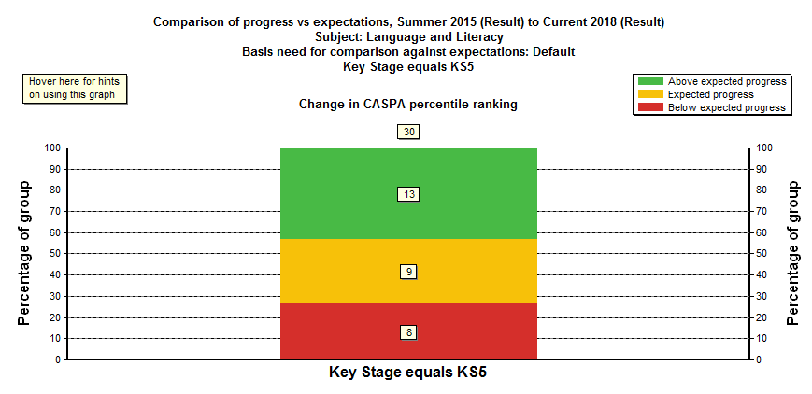
English (2015 – 2018)
- 68% made good or better progress, compared against similar pupils nationwide (CASPA dataset). 43% of pupils made outstanding progress, exceeding CASPA expectations!
- 4 students achieved their FS EL2 qualifications.

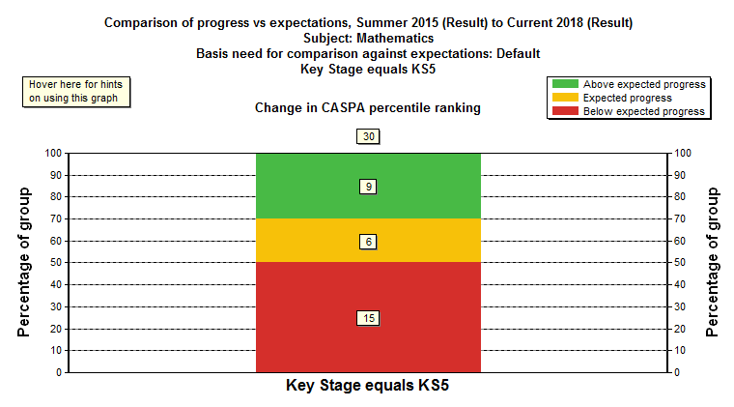
Maths (2015 – 2018)
- 50% made good or better progress, compared against similar pupils nationwide (CASPA dataset)
- 30% of pupils made outstanding progress, exceeding CASPA expectations!
- 4 students achieved Entry Level 2 in FS Maths

PSHE (2015 – 2018)
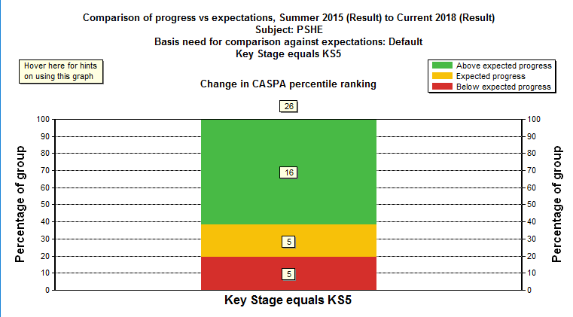
- 81% made good or better progress, compared against similar pupils nationwide (CASPA dataset)
- 62% of pupils made outstanding progress, exceeding CASPA expectations!
- 8 Students achieved an Entry Level 3 accreditation in the OCR Life and Living skills programme at either introductory, award or certificate level.

Exam Results - 2017 / 2018

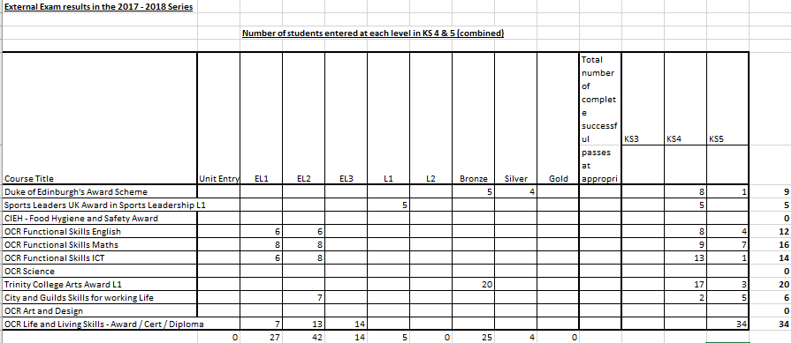

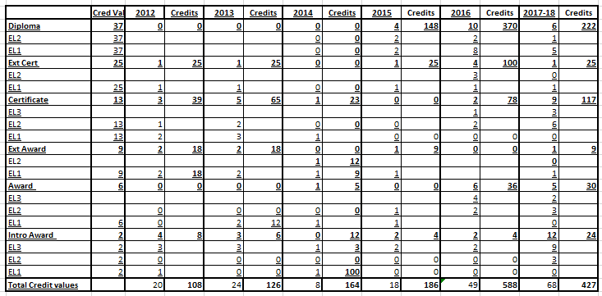
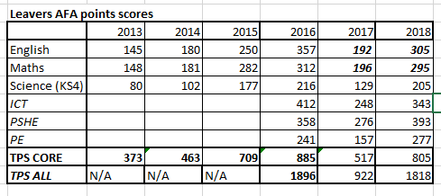
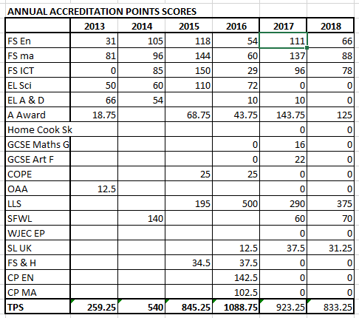
Backdated KS4/5 Accreditation, Credit Values and Achievement for All Results

