Pupil Progress and Achievement Information -
Key Stage 3

(2017 / 2018)

Headline Results
English
- 100% made good or better progress against St. Nicholas criteria, 78% outstanding.

- 100% achieved at least median quartile. 56% made UQ progress.

- 39% at least met national expectations (2 levels); 2 pupils exceeded.

- 8 pupils progressed equivalent to the top 14% of the PG. 4 pupils achieved equivalent to the top 1% of the progression guidance.

- 78% achieved 2+ VA levels, 72% made 3+ VA levels and 3 students achieved 5+.

- 17 pupils achieved at least CASPA expectation and 15 pupils were above expectation

Resulting actions in 2018/19
- To target the higher attaining students in Yr 6 to ensure that they continue to accelerate their progression pathway, through new class structure and learning environments.
- Monitor the impact of this initiative using the fully implemented pupil asset assessment tool

- Review the St. Nicholas School progress definitions to reflect extended challenges required by our pupils showing outstanding progress.
- SHINE curriculum for high needs learners to be implemented to further develop opportunities for knowledge, skills and understanding of themselves and the world around them.

- Embed the introduction of functional English skills accreditation into the KS 3 curriculum

- Enhance partnerships and opportunities created by our KS 3 satellite initiative.

- Moderation of Pupil Asset level judgements at Key Stage meetings.
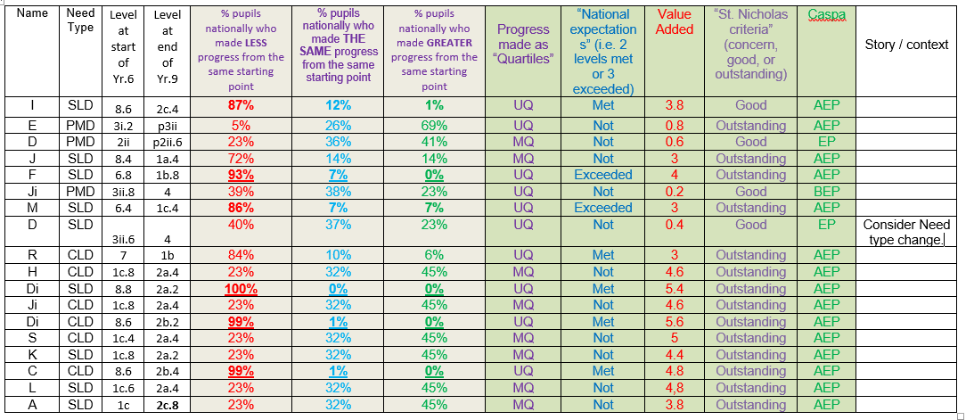

Maths
- 94% made good or better progress against St. Nicholas criteria, 39% achieved outstanding.
- 100% achieved at least the median quartile / 56% achieved at least UQ. 9 pupils made UQ++ progress.
- 78% of pupils made at least 2 VA levels of progress. 67% made at least 3 VA levels of progress and 56% made 4 or more levels of VA progress.
- 17 of the 18 students with a CASPA data record, at least reached this expectation. 72% of pupils achieved above the CASPA expectation – when their performance was compared to other pupils nationwide.
Resulting actions in 2018/19:
- To target the higher attaining students in Yr 6 to ensure that they continue to accelerate their progression pathway, through new class structure and learning environments.
- Monitor the impact of this initiative using the fully implemented pupil asset assessment tool.
- Review the St. Nicholas School progress definitions to reflect extended challenges required by our pupils showing outstanding progress.
- SHINE curriculum for high needs learners to be implemented to further develop opportunities for knowledge, skills and understanding of themselves and the world around them.
- Review the criteria for good and outstanding progress for pupils with PMLD.
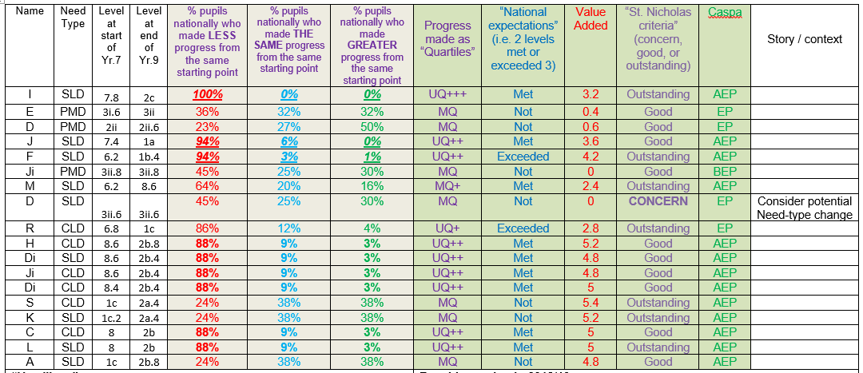
- Moderation of Pupil Asset level judgements at Key Stage meetings.
Science
Headlines:
- 83% made outstanding progress against the St Nicholas School criteria.
- 100% of pupils achieved at least MQ progress and 72% made at least Upper Quartile progress.
- 83% of pupils at least met national expectation (2 levels). 67% of pupils exceeded the national expectation.
- 67% of pupils made at least 2 VA levels. 56% of pupils made 3 levels of VA progress. 44% made at least 5 VA levels!
- 5 pupils met and 13 pupils achieved above the CASPA expectation
Resulting Actions in 2018/19
- To target the higher attaining students in Yr 6 to ensure that they continue to accelerate their progression pathway, through new class structure and learning environments.
- Monitor the impact of this initiative using the fully implemented pupil asset assessment tool
- Review the St. Nicholas School progress definitions to reflect extended challenges required by our pupils showing outstanding progress.
- SHINE curriculum for high needs learners to be implemented to further develop opportunities for knowledge, skills and understanding of themselves and the world around them.
- Review science planning and purchase the EQUALS schemes of work to ensure breadth of coverage of the whole science curriculum.
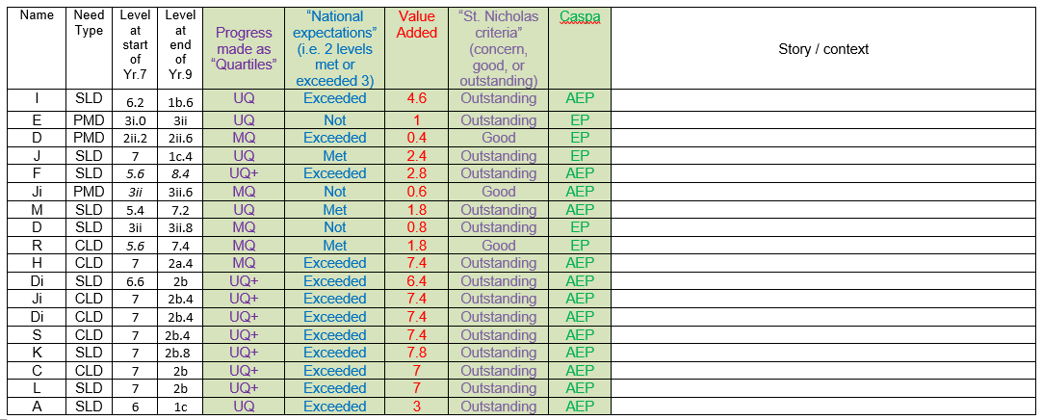
- Continue Pupil Asset moderation meetings to ensure teachers are making consistent and accurate assessment of student attainment.
P.E.
- 83% made outstanding progress against St. Nicholas criteria.
- 78% of pupils met the nationally expected 2 levels of progress across KS3.
- 83% at least exceeded 2 whole levels of progress.
- 72% of pupils made at least 3 Value Added (sub) levels of progress. 56% made 4 VA lvls and 4 pupils made 5 VA levels of progress!
- 89% of students achieved above expected progress on CASPA.
Resulting Actions in 2018/19
- PE Enrichment groups for KS3 on-site and satellite classes.
- Teachers of PE enrichment groups to record student progress at least termly using Pupil Asset.
- Extension opportunities and inter-school events provided to challenge higher-attaining students.
- To target the higher attaining students in Yr 6 to ensure that they continue to accelerate their progression pathway, through new class structure and learning environments.
- Monitor the impact of this initiative using the fully implemented pupil asset assessment tool
- Review the St. Nicholas School progress definitions to reflect extended challenges required by our pupils showing outstanding progress.
- Review the criteria for good and outstanding progress for pupils with PMLD.
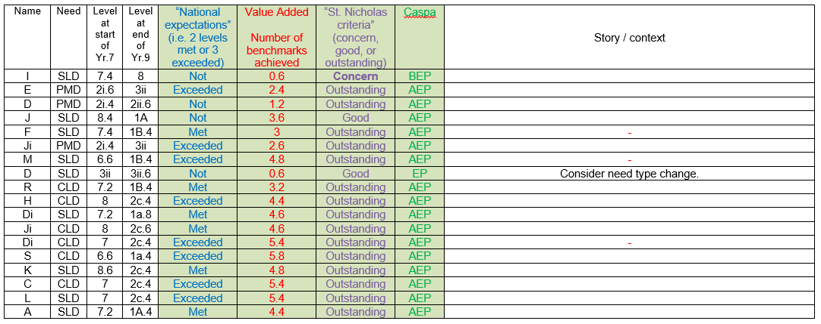

Computing
- 100% made good or better progress against St. Nicholas criteria, 83% outstanding.
- 78% at least met the national expectation. 50% exceeded the national expectation.
- 78% made at least 2 VA (sub) levels. 56% of pupils achieved 3+ VA levels.
- 78% pupils achieved at least expected progress on CASPA and 67% achieved above expected progress.
Resulting action in 2018/19
- To target the higher attaining students in Yr 6 to ensure that they continue to accelerate their progression pathway, through new class structure and learning environments.
- Monitor the impact of this initiative using the fully implemented pupil asset assessment tool.
- Review the St. Nicholas School progress definitions to reflect extended challenges required by our pupils showing outstanding progress.
- Review the criteria for good and outstanding progress for pupils with PMLD.
- Ensure that students have access to a wide range of technologies and computing opportunities.
- Continue Pupil Asset moderation meetings to ensure teachers are making consistent and accurate assessment of student attainment
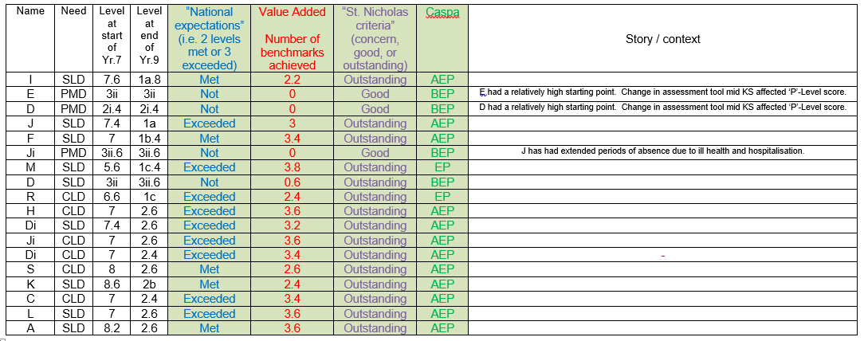

PSHE:
- 100% of pupils made good or outstanding progress against St. Nicholas criteria. 61% made outstanding progress.
- 83% of pupils at least met and 22% exceeded national expectations
- 83% of pupils made at least 2 VA levels of progress. 61% of pupils made 3 VA levels of progress and 50% of pupils made 4 VA progress levels.
- On CASPA 17 of 18 students achieved above expected progress.
Resulting action in 2018/19
- To target the higher attaining students in Yr 6 to ensure that they continue to accelerate their progression pathway.
- Review the St. Nicholas School progress definitions to reflect extended challenges required by our pupils showing outstanding progress.
- Review the criteria for good and outstanding progress for pupils with PMLD.
- To maximise opportunities for KS 3 pupils to accelerate their learning in all areas of the PSHE curriculum throughout the day, including lunch times, social times and daily living activities.
- Ongoing monitoring of student’s progress in PSHE using the fully implemented pupil asset assessment tool.
